W1D4 solutions
Question 1:
package work.D3.prob1a;
import java.util.*;
public class Subsetsum {
public static boolean[][] subsetSumDP(int[] set, int sum) {
int n = set.length;
boolean[][] dp = new boolean[n + 1][sum + 1];
for (int i = 0; i <= n; i++)
dp[i][0] = true;
for (int i = 1; i <= n; i++) {
for (int j = 1; j <= sum; j++) {
if (set[i - 1] <= j)
dp[i][j] = dp[i - 1][j] || dp[i - 1][j - set[i - 1]];
else
dp[i][j] = dp[i - 1][j];
}
}
return dp;
}
public static void findSubsets(int[] set, int n, int sum,
List<Integer> current, boolean[][] dp,
List<List<Integer>> allSolutions) {
if (sum == 0) {
allSolutions.add(new ArrayList<>(current));
return;
}
if (n == 0)
return;
if (dp[n - 1][sum])
findSubsets(set, n - 1, sum, current, dp, allSolutions);
if (sum >= set[n - 1] && dp[n - 1][sum - set[n - 1]]) {
current.add(set[n - 1]);
findSubsets(set, n - 1, sum - set[n - 1], current, dp, allSolutions);
current.remove(current.size() - 1);
}
}
public static void main(String[] args) {
int[] S = {3, 4, 7, 8};
int K = 15;
boolean[][] dp = subsetSumDP(S, K);
int n = S.length;
System.out.println("(a) Subset with sum " + K + " exists: " + (dp[n][K] ? "True" : "False"));
if (!dp[n][K]) {
System.out.println("No subsets found.");
return;
}
List<List<Integer>> allSolutions = new ArrayList<>();
findSubsets(S, n, K, new ArrayList<>(), dp, allSolutions);
System.out.println("(b) One solution: " + allSolutions.get(0));
System.out.print("(c) All solutions: ");
for (List<Integer> subset : allSolutions)
System.out.print(subset+", ");
}
}
Output:
(a) Subset with sum 15 exists: True
(b) One solution: [8, 4, 3]
(c) All solutions: [8, 4, 3], [8, 7],
Question 2:
a
Element | 0 | 1 | 2 | 3 | 4 | 5 | 6 | 7 | 8 | 9 | 10 | 11 | 12 | 13 | 14 | 15
– | T | F | F | F | F | F | F | F | F | F | F | F | F | F | F | F
3 | T | F | F | T | F | F | F | F | F | F | F | F | F | F | F | F
4 | T | F | F | T | T | F | F | T | F | F | F | F | F | F | F | F
7 | T | F | F | T | T | F | F | T | T | F | F | T | T | F | F | F
8 | T | F | F | T | T | F | F | T | T | F | F | T | T | F | T | T
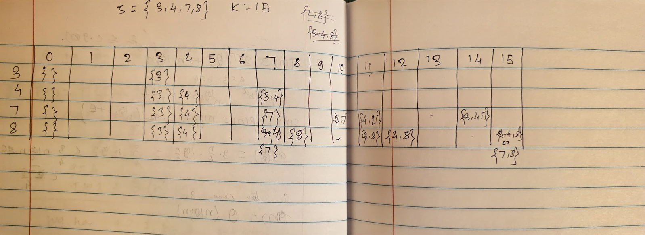

b. One solution : {3,4,8}
c. All solutions : {3,4,8} and {7,8}
Question 3. 0/1 knapsack
Weight: | 1 | 2 | 3 | 4 | 5 | 6 | 7 | 8 | 9 | 10 | 11 | 12 | 13 | 14 | 15 | 16 | 17 | 18 | 19 | 20
d,2,16 | 0 | 16 | 16 | 16 | 16 | 16 | 16 | 16 | 16 | 16 | 16 | 16 | 16 | 16 | 16 | 16 | 16 | 16 | 16 | 16
a,5,25 | 0 | 16 | 16 | 16 | 25 | 25 | 41 | 41 | 41 | 41 | 41 | 41 | 41 | 41 | 41 | 41 | 41 | 41 | 41 | 41
b,6,12 | 0 | 16 | 16 | 16 | 25 | 25 | 41 | 41 | 41 | 41 | 41 | 41 | 53 | 53 | 53 | 53 | 53 | 53 | 53 | 53
e,7,28 | 0 | 16 | 16 | 16 | 25 | 25 | 41 | 41 | 44 | 44 | 44 | 53 | 53 | 69 | 69 | 69 | 69 | 69 | 69 | 81
c,8,24 | 0 | 16 | 16 | 16 | 25 | 25 | 41 | 41 | 44 | 44 | 44 | 53 | 53 | 69 | 69 | 69 | 69 | 69 | 69 | 81
Maximum value = 81, Items included ={d,a,b,e}

Question 4 : Fractional knapsack
The maximum allowable total weight in the knapsack is Wmax = 20.
Item | a | b | c | d | e
value | 25 | 12 | 24 | 16 | 28
Weight | 5 | 6 | 8 | 2 | 7

Now value:weight :- a:5, b:2, c:3, d:8, e:4
items | d | a | e | ¾ of c
Wmax - weight | 20 – 2 = 18 | 18 – 5 = 13 | 13 – 7 = 6 | 6 – 6 ( ¾ *8)
value | 16 | 25 | 28 | 18

Items selected : d,a,e, and ¾ c
Total weight used : 2+5+7+6 = 20
Maximum value : 16+25+28+18( ¾ of 24) = 87
Question 5:
class Solution {
public int climbStairs(int n) {
if (n<=0) return 0;
if(n==1) return 1;
if(n==2) return 2;
int[] arr = new int[n+1];
arr[1] =1;
arr[2] = 2;
for(int i=3;i<=n;i++){
arr[i]=arr[i-1]+arr[i-2];
}
return arr[n];
}
}
Question 6:class Solution {
public int rob(int[] nums) {
int len = nums.length;
if(len==1) return nums[0];
int[] loot= new int[len];
loot[0] = nums[0];
loot[1]=Math.max(nums[0],nums[1]);
for(int i=2;i<len;i++){
loot[i]=Math.max(loot[i-1],loot[i-2]+nums[i]);
}
return loot[len-1];
}
}

